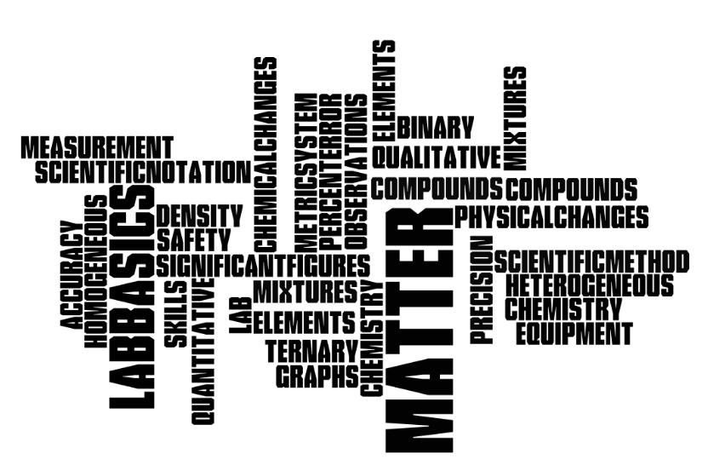

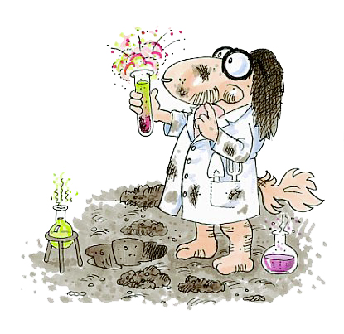

Homework Due : ___________________

Exam Dates:
Free Response ___________________ Multiple choice ___________________

Textbook chapters:
1~ Introduction to Chemistry; 2~ Matter & Change; 3~ Scientific Method

Study Guide Outline for Topic # 1
-Introduction
Chemistry: The study of matter and the changes that matter undergoes

Investigation of chemistry:
Using the scientific method (laboratory experiments)
Theory:  explanation supported by many  experiments and answers 'why' | Law:  a relationship in nature supported by many  experiments

-Science and lab activities:

Observations:
Quantitative: An observation that describes using numbers, measurements or amount.

Measurements:

- Metric System (Table C)
- Scientific Notation
- Significant figures used when reporting scientific data because they give the reader an idea of how well you could actually measure data. Significant figures are dependent on the equipment markings you are using.
- Include units for measurements! (Table D)
Remember the rules:
  - ALL non-zero numbers (1,2,3,4,5,6,7,8,9) are ALWAYS significant.
  - Leading Zeros within a number are NEVER significant. Both .023 and 0.0019 contain only 2 significant figures.
  - Trailing Zeros WITHOUT a decimal point are NOT significant. Thus, 470,000 has only two significant figures. BUT 270. and 1.90 each have 3 significant figures.
  - Squished zeros between significant numbers are ALWAYS significant. Both 1001 and 3.020 each have 2 significant figures.
Addition and Subtraction with Significant Figures
- When measurements are added or subtracted, the answer can contain no more decimal places than the least accurate measurement.
Multiplication and Division with Significant Figures
- When measurements are multiplied or divided, the answer can contain no more significant figures than the least accurate measurement.
- Density (Table T)
- Accuracy (percent error - Table T) versus Precision

Qualitative: An observation non numerical, description of shape, color, odor or temperature.
- States of matter
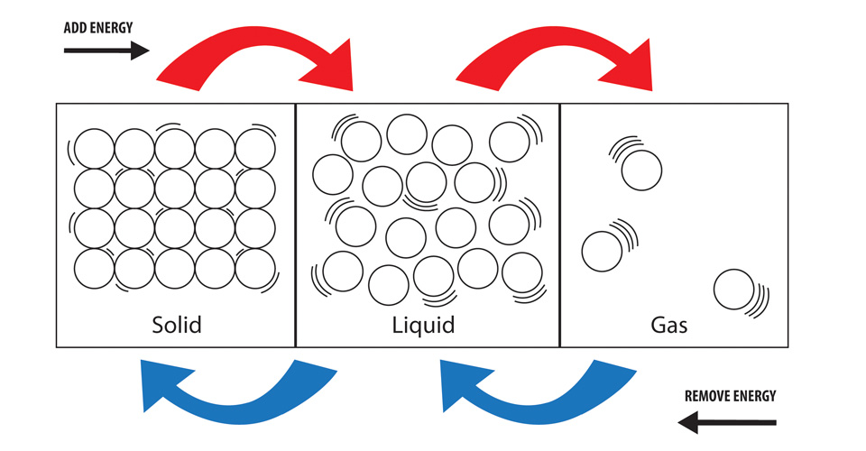

Identify :
Physical versus Chemical Properties

Physical versus Chemical Changes

Classification of Matter:
Matter
takes up space and has mass

Mixture
variable composition
Pure Substance
definite composition; homogeneous

Element
made up of atoms, cannot be further separated by physical or chemical means
Compound
chemical combination of two or more atoms
Solution
particles atoms, ions, or compounds, won’t scatter light

Heterogeneous Mixture
not uniform throughout
Homogeneous Mixture
uniform throughout but proportions not set
Homogeneous Mixture
uniform throughout but proportions not set

VOCABULARY
Chemistry Elements
Scientific method Compounds (binary vs. ternary)
Qualitative Mixtures (homogeneous vs. heterogeneous)
Quantitative States of Matter (solid, liquid, gas)
Density physical vs. chemical changes
Accuracy physical vs. chemical properties
Precision

Matter and Lab Basics Homework
Basics of Chemistry
TEXT Pages 28-30
38.____________________________________________________________________________________________________________________________________________________________________
________________________________________________________________________________________________________________________________________________________________________
Pages 28-30
50._____________________________________________________________________________________________________________________________________________________________________
________________________________________________________________________________________________________________________________________________________________________
Pages 28-30
81._________________________________________________________________________________
____________________________________________________________________________________
____________________________________________________________________________________
____________________________________________________________________________________
Pages 55-58
95. _________________________________________________________________________________
____________________________________________________________________________________
____________________________________________________________________________________

Pearson SuccessNet Online
Follow the slides and Complete online questions Chapter 1 → level activities → concepts in action:
What would happen in a world without chemistry?

Pearson SuccessNet Online
Watch the video Chapter 1 → level activities → What good chemistry can do?

Measurements
TEXT Pages 28-30
55.

Pages 95-98
57. b.______ c. ______ f.______
58. a. ______ b.______ f. ______

59.
A E

70. ____________________________________________________________________________________
____________________________________________________________________________________
____________________________________________________________________________________

83. ____________________________________________________________________________________


101.

107.

Page 99

1. ____________
2. ____________
3. ____________
4. ____________

8. ________ _________ _______

Pearson SuccessNet Online
Watch The Video Chapter 3 → Level Activities → Being precisely Accurate.

Pearson SuccessNet Online
Follow the slides and Complete online questions Chapter 3 → level activities →
concepts in action: SI Units! Exactly!

Pearson SuccessNet Online
Using the Kinetic art Activity answer online questions Chapter 3 →
3.1 Kinetic Art Precision in measurement

Matter
Pages 28-30
34.____________________________________________________________________________________________________________________________________________________________________
___________________________________________________________________________________________________________________________________________________________________________________________________________________________________________________________
Pages 28-30

73._________________________________________________________________________________
____________________________________________________________________________________
Pages 55-58
41._________________________________ _________________________________________

Pages 55-58
45._________________________________________________________________________________
____________________________________________________________________________________
____________________________________________________________________________________

46.
- _________________________________________________________________________
- _________________________________________________________________________
- _________________________________________________________________________
- _________________________________________________________________________
Pages 55-58
48. _________________________________________________________________________________
____________________________________________________________________________________
50.

A ________________
B ________________
C________________
D________________
E________________
F________________
G________________
H_____________

51. _________________________________________________________________________________
____________________________________________________________________________________
54.
- _________________________________________________________________________
- _________________________________________________________________________
- _________________________________________________________________________
- _________________________________________________________________________
60.
- _________________________________________________________________________
- _________________________________________________________________________
- _________________________________________________________________________
- _________________________________________________________________________

63. _________________________________
64. _________________________________
65. ____________________________________
66. ____________________________________

72.

- _________________________________
- _________________________________
- _________________________________
- _________________________________

Pages 55-58
73.

- _________________________________
- _________________________________
- _________________________________
- _________________________________
- ________________________________

81. ________________________________________________________________________________
____________________________________________________________________________________
____________________________________________________________________________________
95. _________________________________________________________________________________
____________________________________________________________________________________
____________________________________________________________________________________

Page 59
5. ____________
6. ____________
7. ____________
8. ____________
9. ____________

